Code:

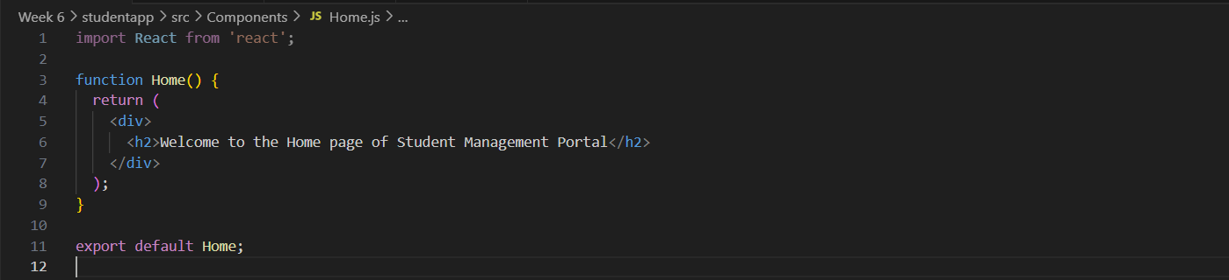Home.js

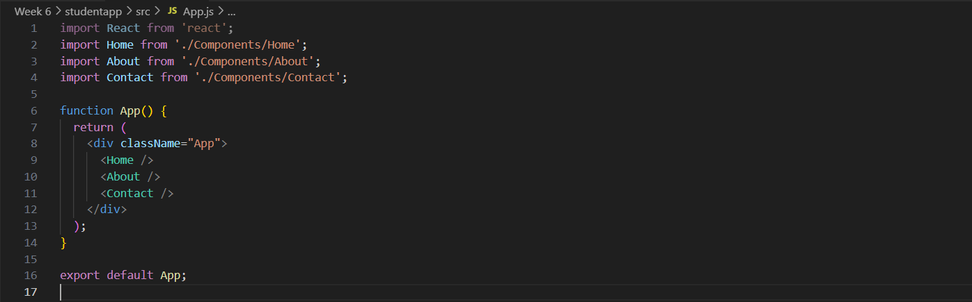App.js

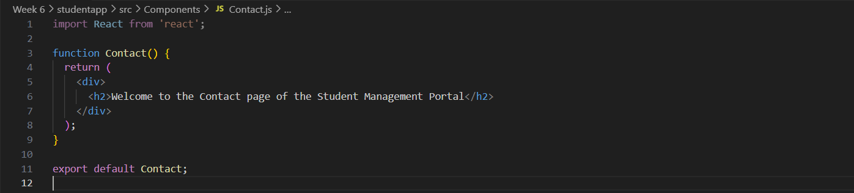Contact.js

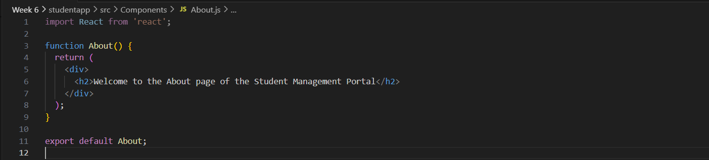About.js

Output: